Overview
ExtJS View Builder is an Eclipse plug-in to help build GUI/views for ExtJS applications.

You can drag & drop components to visually build your GUI - easy and fun just like playing Lego! And what you see during "play" is what you will get at run time.

Another cool feature is the plug-in can be used to build reflective views. A reflective view reflects back-end data model and supports auto data binding when it loads from or submits to back-end. The plug-in provides a Wizard for creating reflective from Java Class that represents back-end data model.

Install and configure ExtJS View Builder
You need to download zip file “ExtJSViewBuilderFeature.zip” first and then select menu “help -> Install new Software…” in Eclipse to install the plugin.

Next is configuration. Click menu “Windows -> preferences” and select “ExtJS View Builder” section:
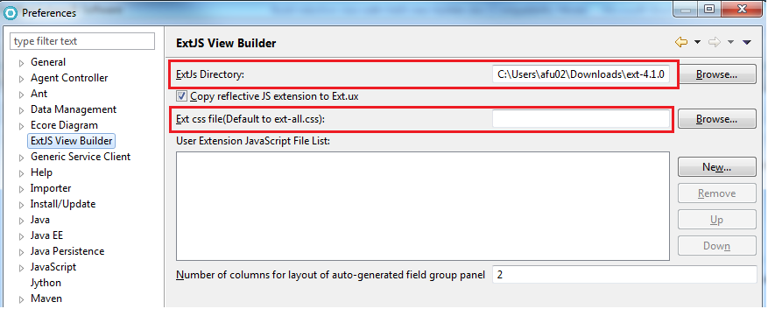

Note that:
- “ExtJs Directory” is mandatory and must be configured correctly. ExtJS View Builder Plugin works fine with ExtJS version 4.1 and up
- For Ext version 5.1 and up, Ext css file must be selected

Build GUI in a “Visual” way
Most people may agree with me that dealing with a mix of HTML, JSP and JavaScript pieces is no fun. It takes huge efforts to write/type almost every single line of source code and the code still easily gets messy and hard-to-read. Worst of all, you may have to configure, deploy and run the whole application to just get "look-and-feel" of a single page!

With ExtJS View Builder, you don’t have to suffer this. It provides a visual way to build your GUI.

We know an ExtJS GUI/view is made up of components. ExtJS View Builder allows you to pick component from a palette and drop it at the right place in components tree. You can also edit properties of selected components such as name, title, layout, etc.

The plug-in extends Eclipse IDE workbench by adding a set of Editor and Views:
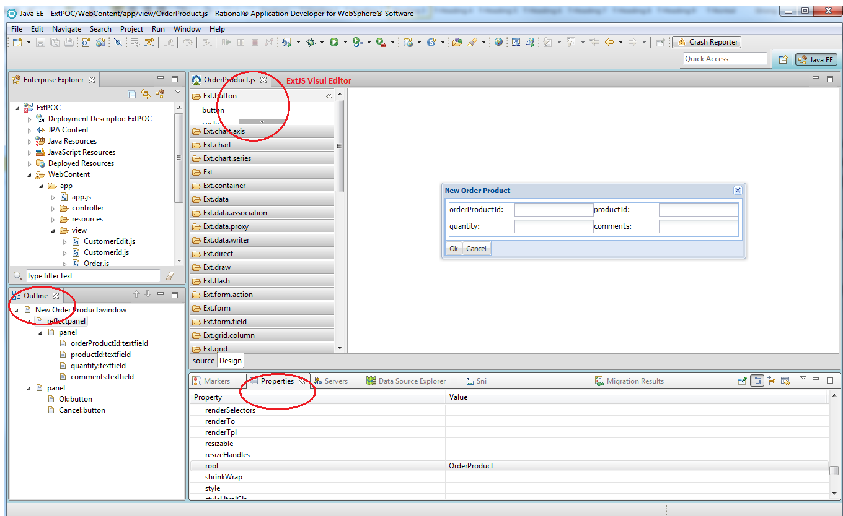

ExtJS Visual Editor
As key part of the plugin, it consists of 2 pages – Source page and Design page.

Source page
Source page is a JavaScript editor. You can edit JavaScript source code here and change you made will be in-sync with Design page and other parts right away.

Design page
Design page comes with a palette and an embedded browser.

Palette
Whenever the plugin is initialized, it scans and parses all ExtJS source files to get a list of available ExtJS components. The list is shown in groups on design palette so you can pick what you need.

Browser
Embedded browser provides real-time live preview of the GUI you’re building.

Components Tree
The “Outline” Eclipse View in this workbench renders a component hierarchy tree. To add a component to your GUI, you only need to drag it from palette and drop over the node representing parent component.

Properties
The plugin uses eclipse “Properties” View to edit configurable properties of selected component.

How the plugin knows which properties are available for which component? The answer is in source code. ExtJS uses “@cfg” annotation to indicate property configurable in source code of comopent. For example: @cfg {Boolean/Object} resizable. The plugin populates property list based on information collected from source code scan.

Components also inherit properties. For example, configurable properties defined in Ext.Component will show for components such as Ext.panel.Panel, Ext.grid.Panel because they all extend from Ext.Component

What if a property is not addressed by the code scan? Don’t worry, the plugin always populates a special item called “customizedProperties”, which allows you to add any many properties as you like. For each property, you need to specify “name”, select “type” then enter value:
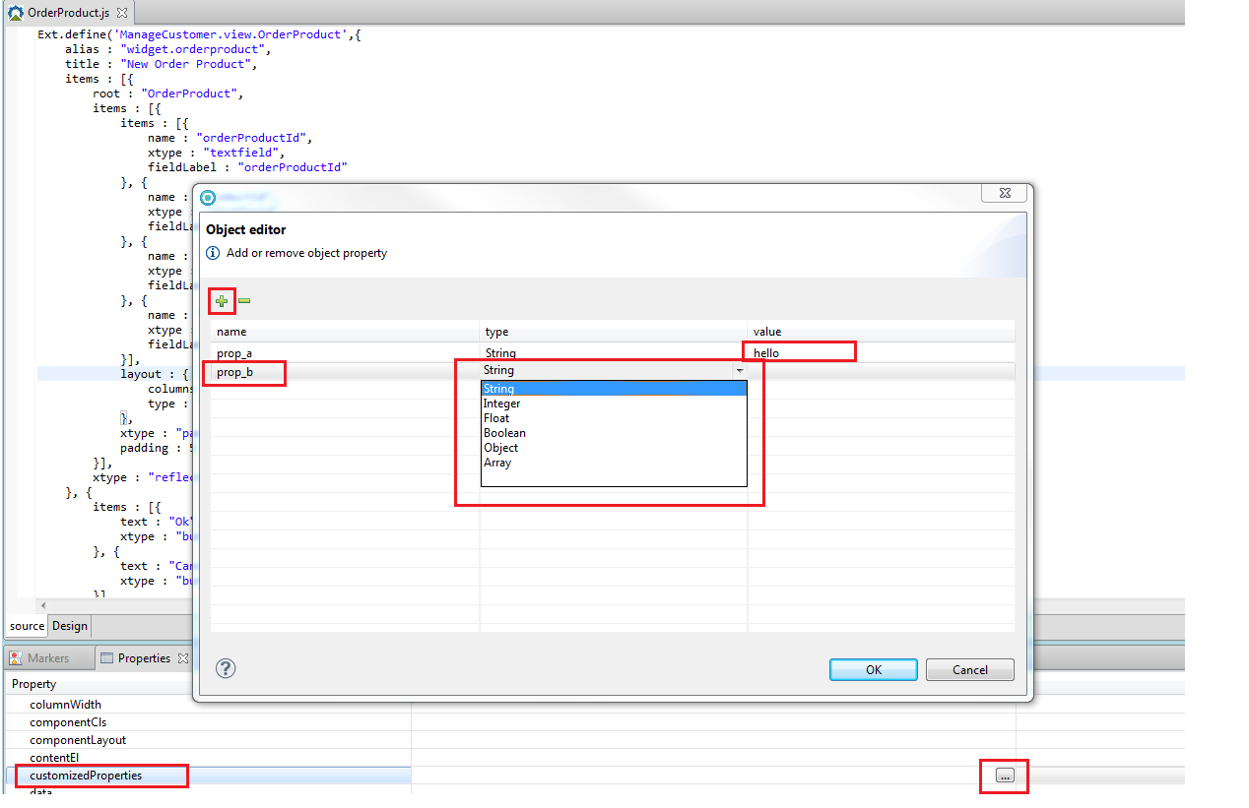

Another option is editing source code directly using ExtJS Visual Editor. The JavaScript source code is pretty-formatted and won’t be too difficult to find place to type in properties.

Make your GUI reflective

What is a “reflective” View?

In a MVC architecture, user interacts with Views, which display data held in Models. Those interactions are monitored by a Controller, which then responds to the interactions by updating the View and Model, as necessary.

But do we really need extra data Model in front-end as most enterprise applications have back-end data model to manage data and transactions? I believe it makes more sense to connect front-end Views directly to back-end data model.

In order to connect to back-end data model, we better make Views “reflective”. Data model are typically Java classes in Java applications and here is an example:

public class Customer implements Serializable {
@Id
private String customerId;
private String firstName;
private String lastName;
private String homePhone;
private String cellPhone;
private String addr1;
private String addr2;
private String city;
private String postalCode;
private String email;
@OneToMany(mappedBy="customer", fetch = EAGER)
private Set<Order> ordersCollection;
}

Member “ordersCollection” of Class Customer reference another Class:
public class Order implements Serializable {
@Id
private String orderId;
private Date placedDate;
private BigDecimal price;
private String status;
private String comments;
@ManyToOne
@JoinColumn(name="customer")
private Customer customer;
}

Then we build a View “reflecting” structure of Class Customer:
- Fields such as firstName, lastName, cellphone reflect on as fields on the view.
- Field “orderCollection” reflects as a collection of children reflective components, each representing an order.
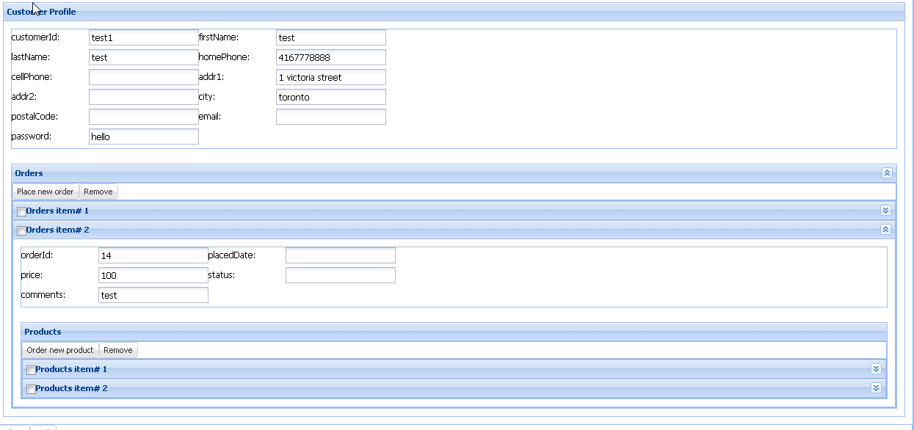

Reflective Views maintains mappings to back-end Models and this makes automatic two-way data binding (loading and submission) possible, as long as we use JSON to exchange data between front-end and back-end.

Benefits of being reflective

Benefits of reflective views are obvious: no extra data model needed in front-end. By connecting GUI directly to back-end, we can:

- Greatly reduce development efforts
- Lower chance of inconsistent data

User extension “reflective”
The Plugin comes with a user extension called “reflective”, which consists of a few components:

Ext.ux.reflective.Panel
Extended from Ext.panel.Panel, a reflective Panel renders back-end Object on GUI and supports auto data-binding for both loading and submission. If mapped Object has child objects, reflective Panel can contain children Panels mapped to child objects accordingly.

Config options
root : String
Class name of reflected top-level back-end model. So all reflective components in the same hierarchy tree must have same value of “root”.

path : String
If a reflective component is mapped to a member or field in a back-end model, “path” is used to specify member/field name.
urlForLoad : String
URL link for loading data from back-end by load() method call.

paramsForLoad : Object
Parameters passed to back-end for loading

urlForSubmit : String
URL link for data submission to back-end by submit() method call.

paramsForSubmit : Object
Parameters passed to back-end for submission

Properties
loadedData : Object
Data returned from back-end after load() is called

submitResponseData : Object
Data returned from back-end after submit() is called

Methods
load( options: Object ): Object
Load data from a remote server by sending an AJAX request and then load hierarchy of "Reflective" components recursively.
The parameter “options” is optional here. If not given, url and parameters will be taken from Config options.

submit( options: Object ): Object
Submit data to remote server by sending an AJAX request.
The parameter “options” is optional here. If not given, url and parameters will be taken from Config options.

Ext.ux.reflective.Collection
Extended from Ext.ux.reflective.Panel, it deals with Array or Collection instead of individual Object

Config options
template : Ext.ux.reflective.Panel
Template is a reflective component used to populate items in collection.

autoPaging : Boolean
Items will be grouped into pages if autoPaging is true. False by default.

itemsPerPage :Number
Specified how many items per page when autoPaging is on.

Methods
addItem( item: Object ): Object
Add an item to GUI only, no AJAX call to back-end

removeItem( item: Object ): Object
Remove an existing item from GUI only, no AJAX call to back-end

Ext.ux.reflective.GridPanel
Extended from Ext.grid.Panel and Ext.ux.reflective.Collection, it renders a collection of Object as a grid – each row represents one object and columns mapped to object fields.

Build reflective View from Java Class

A Wizard can guide developers to build reflective views from Java Classes. Screen shots below show how to build a reflective view from Java Class Customer step by step:

Step 1: Select wizard
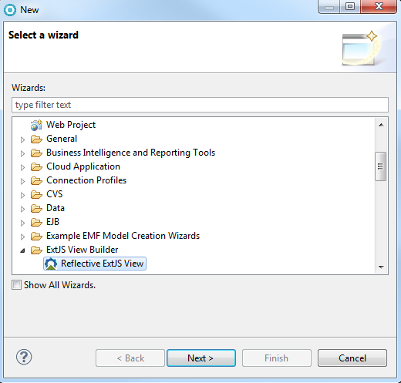

Step 2: Enter “Namespace”, “Class Name” and “File name” fields for generating ExtJS source file, check “build from Java Class” and then click “Browse…” button to select Java class:
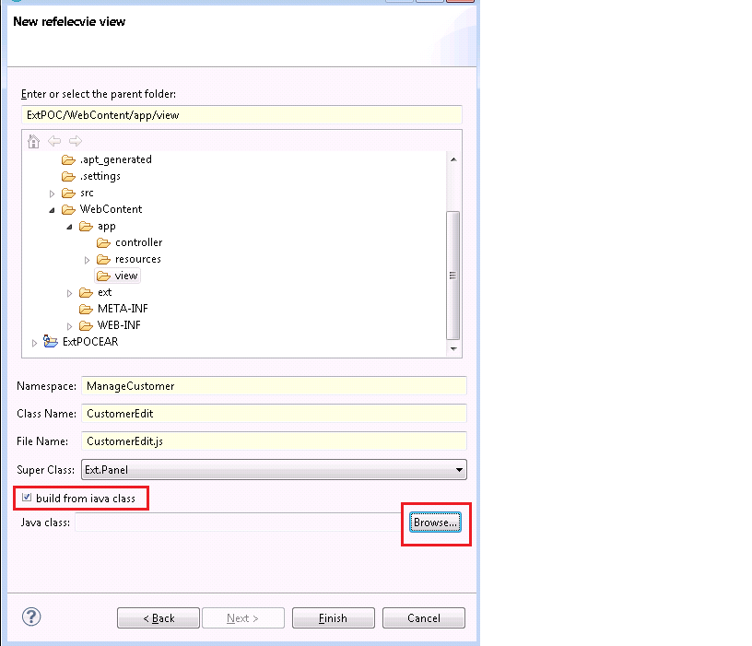

Step 3: Select Java Class
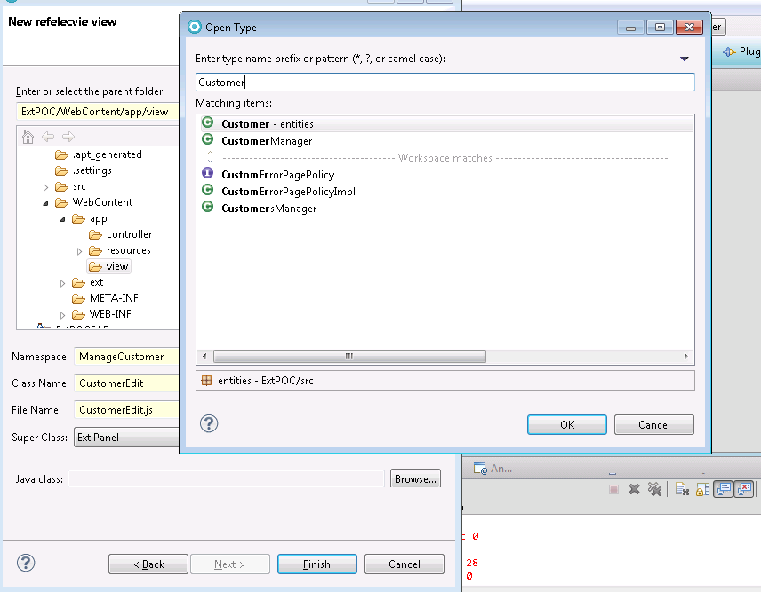

Step 4: Reflective view generated – JavaScript source file “CustomerEdit.js” and below is what it looks in “Design” page
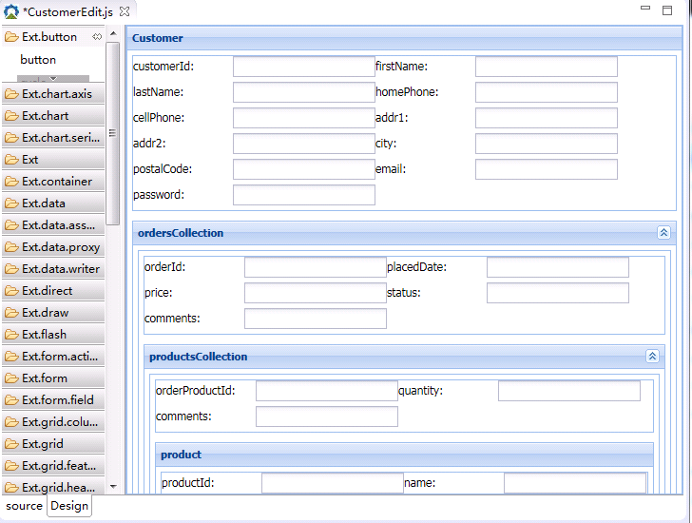

Step 5: Edit generated View – you can add/remove components or change value of component properties

A sample application
ExtPOC.zip includes source code of a sample application.

This application implements basic Customer-Order management functions such as update customer profile, place/remove order, order/remove product.

Front-end part of the application is made up of reflective views and a central controller while back-end integrates Spring, Jackson and JPA technology. For simplicity, it uses Derby database and “DDL.sql” under META-INF provides SQL statement for creating tables.

Application source file structure is shown as below:
